# 

**Project Proposal on**

**Cars Game**

**Bibek Tamang**

**00163021**

**Computing Project**

**Level 5 Diploma in Computing**

**Softwarica College of IT & E-Commerce**

**Kathmandu, Nepal**

**April 9, 2017**

**Table of Contents**

**Introduction 3**

**Aims 4**

**Objectives 4**

**Main Features 4**

**Development Method 5**

**Project Plan 6**

**Work Breakdown Structure (WBS) and Time Estimate 6**

**Milestones 8**

**Schedule 8**

**Risk Management 10**

**Identification of risks: 10**

**Accessing risk impacts: 10**

**Actions to alleviate risks: 10**

**Risk control: 11**

**Configuration Management 12**

**Conclusion 13**

**References 14**

# **Introduction**

The project ‘***Cars Game***’ is a desktop mini-game project. It is a desktop game application built in java focusing on the multitasking capacity of a player. It is a multitasking brain game which tests individual’s personal brain capacity to focus on two tasks at the same time.

The game consists of two cars; red and blue. The player controls these two cars at the same time. Each car has its own separate track with two lanes for each track. Cars can change the lanes of a track through separate keystrokes for each car. Both the cars need to collect all the circles and also avoid the squares on the track. In order to play the game, a player needs to login using simple username and password. New players to the game must register through registration form. Each player’s profile is created after registration to the game. Profile covers some player’s personal details with username and password. Player’s profile also includes personal high score. Also, a player can see the game’s high score scored by other players in the game. These profiles and scores are stored in a database choosing any one database platform. The database is connected to the application at run-time. Though, ***Cars Game*** seems as a simple game but it is hard to play than expectations.

In today’s competitive world, people are busy with their time schedules. Busy day-to-day routines are making people stressed out. Repeating schedules and work is very frustrating to human minds. Our brain and mind need refreshments from time to time. In the solution to this, games have been popular in the present world. Especially, different types of brain games have been developed that facilitates in increasing brain or mind capacity.

Brain games have had great advantages to many gamers today. It has been solution to many busy lives. It’s a kind of brain exercise. Also, it is a short-time break for the routine day-to-day schedules. This helps a player to be energetic and mentally fresh which increases one’s brain capacity to concentrate in his/her daily tasks. The game ***‘Cars Game’*** enables a player’s mind to be involved in multiple tasks.***Cars Game*** focuses in enhancing the multitasking ability of a human brain. The game can act as a brain refresher and activate our mind with new energy to focus on our daily tasks. Since, a player’s brain will be involved heavily, the game is also addictive in nature. Thus, with all these features, the game is best suited for the project.

This project can help in enhancing programming skills for developing desktop based applications. Various new techniques in programming can be explored. It has provided an opportunity to develop creativity in building addictive mini-games. Different types of brain refreshing games can be built in future which tests user’s brain capacity like multitasking, concentrating, creativity and many more. I expect ***Cars Game*** project aids in developing these qualities.

## **Aims**

The main aim of the ***Cars Game*** project is: -

* To build desktop game application which tests the multitasking ability of a human brain.

## **Objectives**

In order to achieve the aim of ***Cars Game*** project, several goals are prepared. These goals refer to the objectives of this project. Objectives of the ***Cars Game*** project are listed below: -

* To analyze and collect requirements for the game
* To decide on level of difficulty
* To produce final requirement specification
* To design static and dynamic model of the application
* To perform coding and develop the application designed
* To perform testing and maintenance
* To document the application development

## **Main Features**

Cars project will have the following list of features: -

* Player registration and login
* Update player profile
* Personal high score and overall game high score
* Main game panel
* Keystrokes to control cars
* Collecting circles
* Avoiding Squares
* Increased difficulty with time
* Scoreboard

For the development of the ***Cars Game*** project, I chose java programming language which is an object-oriented approach to software development. I prefer object-oriented approach as it has several advantages like: -

* Modularity for easier troubleshooting
* Reuse of code through inheritance
* Flexibility through polymorphism
* Effective problem solving

(Robert Half Technology, 2013)

‘Project Libre’ software tool is used to produce project Gantt chart for scheduling the development process. ‘Star UML’ will be used to design various structural and behavioral models of the project. For coding, ‘NetBeans IDE 8.0’ development environment will be used which is one of the famous integrated development environment for object-oriented programming. Java Swing library will also be used to design the game.

## **Development Method**

In software engineering, software development methodology can be defined as a process of splitting a software development work into distinct stages and phases with the aim of better planning and management in the development process where each stage or phase contains its own objective and activities. Out of diverse software development methods, I prefer to use waterfall model.

Waterfall development model is the first process model to be introduced which is very simple to use and easy to understand. As it mainly consists of sequential stages or phases, it is also referred to as ***linear-sequential life cycle model***. (ISTQB Exam Certification)

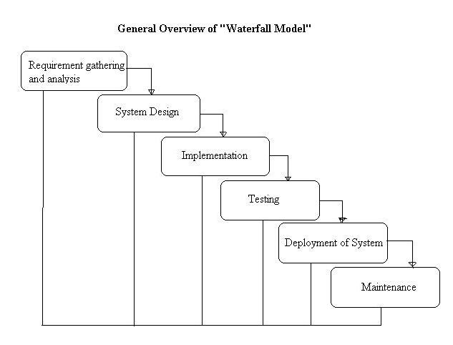

*Figure (1): Overview of waterfall development model*

The main principle of waterfall model is completing the tasks and objective of the current stage before jumping into the next one. This ensures that all activities are performed and objectives are met of each stage in the development. Thus, it is also known as top-down approach where the development process flows from top to bottom of the stages defined.

I chose to use waterfall model because of the following list of features: -

* Best for small and medium sized project
* Appropriate for short time, individual project
* Simple and easy to use and understand
* Works well for project where requirements are very well specified and highly unlikely to change
* Allows for departmentalization and managerial control
* Rigid model – each stage has specific deliverables and a review process
* Process oriented development, step-by-step approach like a car in a car-wash
* Systematic approach and management
* Ensures that the objectives of each phase are fulfilled
* A schedule can be set with deadlines for each stage of development

(Waterfall Model – its advantages)

# **Project Plan**

Project planning is one of the important part of project management. This involves the breakdown of project development work into tasks and activities that are completed in order to complete the project. Time estimations are performed. Schedules are used such as Gantt charts to plan and progress reports can also be developed within the project environment. Re-plan can also be done in case of requirement changes.

I planned to produce Work Breakdown Structure (WBS) with time estimation. Also, the project is divided into significant parts known as milestones. ‘Project Libre’ software tool is used to produce Gantt chart for scheduling.

## **Work Breakdown Structure (WBS) and Time Estimate**

Work Breakdown Structure can be defined as a key project deliverable that organizes the development work into manageable sections. The Project Management Body of Knowledge (PMBOK) defines work breakdown structure as a “deliverable oriented hierarchical decomposition of the work to be executed by the project team.” (Work Breakdown Structure)

In the ***Cars Game*** project, work breakdown structure decomposes the development work into different level of tasks and activities with time estimation. These high-level tasks and activities are performed systematically and delivered within the specified deadlines with the aim to complete the project. The purpose of work breakdown is to reduce complicated activities to a collection of tasks. This has been the important part in project management.

The list of high level activities of ***Cars Game*** Project are as follows: -

* Project proposal
* Analysis specification
* Design Specification
* Implementation
* Testing and Maintenance
* Reporting

Cars Game

Reporting

Design specification

Analysis specification

Project Management

Implementation

User Manual

Scoping

Requirements

Structural Model

Coding

Planning

Testing and Debugging

Final Report

Behavioral Model

Use Case

Monitoring & Control

UI Design

Architecture

*Figure (2): Work Breakdown Chart*

|  |  |  |
| --- | --- | --- |
| **WBS #** | **Task Name** | **Days** |
| 0 | **Cars Project** | 79 |
| 1  1.1  1.2  1.3 | **Project Management**  Scoping  Planning  Monitoring and Control | 13  6  4  3 |
| 2  2.1  2.2  2.3 | **Analysis Specification**  Requirements  Use Case  Architecture | 10  3  4  3 |
| 3  3.1  3.2  3.3 | **Design Specification**  Structural Model  Behavioral Model  UI Design | 22  8  8  6 |
| 4  4.1  4.2 | **Implementation**  Coding  Testing and Debugging | 29  22  7 |
| 5  5.1  5.2 | **Reporting**  User Manual  Final Report | 4  2  2 |

*Table (1): Work Breakdown Structure with Time Estimation*

## **Milestones**

Milestone refers to a significant stage or event in the development of something. They are produced in the planning phase of a software development. Milestones for the ***Cars*** project are produced and listed below in the table.

|  |  |
| --- | --- |
| **Milestone** | **Date** |
| Project Proposal | April 9, 2017 |
| Analysis Specification | April 23, 2017 |
| Design Specification | May 24, 2017 |
| Final Report | July 11, 2017 |

*Table (2): Milestones*

## **Schedule**

Scheduling refers to arrange or plan something to take place at a particular time. The activities, tasks and milestones defined above are scheduled in a Gantt chart with the use of ‘Project Libre’ software tool. The Gantt chart produced is presented here below: -

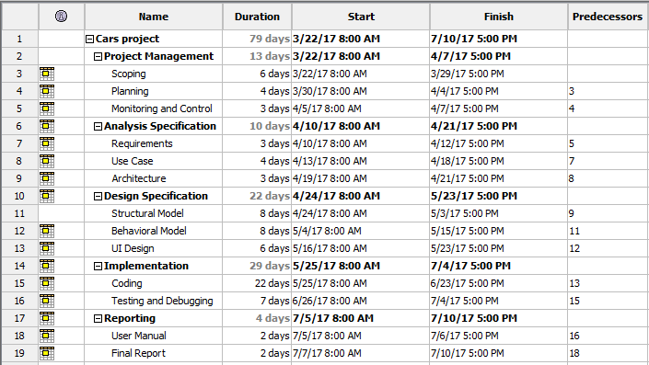

*Figure (2): Gantt chart table*

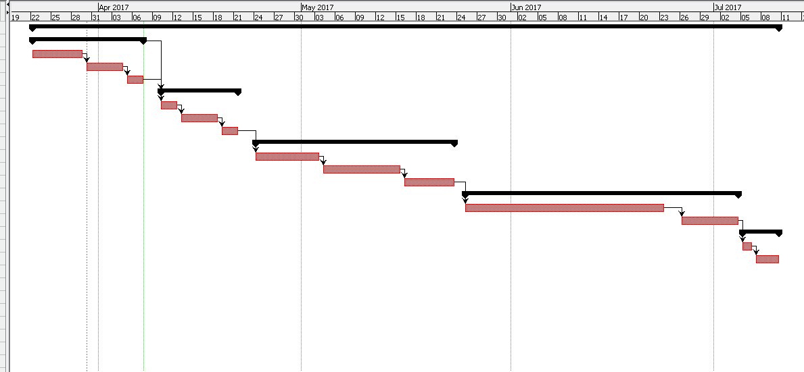

*Figure (3): Gantt chart for the Cars project*

# **Risk Management**

Risk management is the process of identifying, accessing, evaluating, alleviating and controlling risks and threats that a project can overcome during its development period. This has been an important aspect of project management. Its main purpose is to prevent from known threats and to ensure that the project is in condition to face any types of risks that can occur in future development.

(TechTarget, 2016)

The main stages in risk management are: -

* Identification of risks
* Accessing risk impacts
* Actions to alleviate risks
* Risk control

### Identification of risks:

Risks can be of different types such as; event-driven, long term, technical and non-technical. These risks are favorable to occur in any project. Identification of possible risks in a project development is the important part of risk management.

### Accessing risk impacts:

After the identification of risks, level of impacts of those risks are accessed using an equation: -

Impact = Likelihood * Consequence

Risk likelihood and consequence scores are referred from the following score tables: -

|  |  |
| --- | --- |
| **Risk likelihood** | **Score** |
| Low | 1 |
| Medium | 2 |
| High | 3 |

*Table (3): Risk likelihood score*

|  |  |
| --- | --- |
| **Risk consequence** | **Score** |
| Very low | 1 |
| Low | 2 |
| Medium | 3 |
| High | 4 |
| Very high | 5 |

*Table (4): Risk consequence score*

### Actions to alleviate risks:

Based upon the level of impact, risks are defined to be normal or critical. And based upon the type of risks, actions are defined in order to deal with the identified risk. These actions can be of three types: -

* Avoidance
* Deflection
* Contingency

### Risk control:

Risk management isn’t all about the above activities. It further continuously monitors the risks as the development process progresses and be prepared to deal with them. Thus, it is the last but not the least stage of risk management process.

|  |  |  |  |  |
| --- | --- | --- | --- | --- |
| **Risk** | **Likelihood** | **Consequences** | **Impact** | **Actions** |
| Improper scheduling of project tasks and activities | 2 | 5 | 10 | * Re-analyze and perform best decomposition of the development work. * Estimate time referring to the deadlines and task load. |
| Software tool crash during the development process. | 1 | 4 | 4 | * Provide backup to the project documents and codes. * Use of online backup such as GitHub. * Regular updating and patching. |
| Bad UI design of the game | 2 | 4 | 8 | * Consistent design. * Use of relevant and consistent colors. * Perform usability testing. * Smooth movement of objects during the game run-time. |
| Health issues and illness | 2 | 5 | 10 | * Maintain hygienic health and habits. * Recover as soon as possible. * Track the project status and continue with new strategy to complete the project. |
| Lack of player involvement  during requirement capture of the game | 3 | 4 | 12 | * Motivating players to decide on the difficulty level, game features and also interface design. * Best estimation of the game requirements by oneself in the absence of player’s suggestion. |

*Table (5): Risk management table*

# **Configuration Management**

Configuration management is a systematic management approach to manage and control the changes that occurs during the development process. It aids in coordination in software development projects. It also provides backup to the development so that we can rollback to previous version if needed.

CP-Project/

Analysis specification

Requirements

Use Case

Architecture

Design specification

Structural Model

Behavioral Model

UI Design

Implementation

Coding

Testing and Debugging

Project management

00163021_BibekTamang_Proposal.docx

Reporting

User Manual

Final Report

*Figure (4): Directory structure for configuration management*

I chose GitHub for the configuration management in my project development. The above diagram provides the directory structure of my project. There are five main directories and also subdirectories in some directories. It is the repository created that connects with GitHub to store project documents like proposals, diagrams, images and codes in the remote server of GitHub. GitHub also provides backup feature where a user can rollback to old versions whenever needed.

# **Conclusion**

***Cars Game*** is a simple desktop game application which tests the multitasking ability of a player. The game is also addictive and provides a type of mental refreshment. This project proposal provides a brief description of the game. Introduction to project features, its main aim and objectives were analyzed and presented here in this report. Project scoping, planning and monitoring was performed. Choices of development method, programming language, and software tools were done for the development of the project. Work breakdown structure was performed and milestones were identified. Scheduling was done by producing Gantt chart for the project.

Not only this, risk assessment was also performed which included identification of risks, assessment of impacts, actions and risk controls. For the accommodation of changes during development process, configuration management was also done which consists of directories, sub-directories and backups. Finally, the report provides an overall structure of the development process of the ***Cars Game*** project.

# **References**

Robert Half Technology. (December 26, 2013) *4 Benefits of Object-Oriented Programming* [online] Available at: <https://www.roberthalf.com/technology/blog/4-benefits-of-object-oriented-programming> [Accessed on March 28, 2017]

*What is Waterfall model and list its advantages, disadvantages* [online] Available at: <http://jobsandnewstoday.blogspot.com/2013/04/what-is-waterfall-model.html> [Accessed on March 30, 2017]

ISTQB Exam Certification *What is Waterfall model- advantages, disadvantages and when to use it?* [online] Available at: <http://istqbexamcertification.com/what-is-waterfall-model-advantages-disadvantages-and-when-to-use-it/> [Accessed on March 30, 2017]

Workbreakdownstructure.com *Work Breakdown Structure (WBS)* [online] Available at: <http://www.workbreakdownstructure.com/> [Accessed on April 5, 2017]

TechTarget. (August, 2016) *Definition of Risk Management* [online] Available at: <http://searchcompliance.techtarget.com/definition/risk-management> [Accessed on April 8, 2017]